**Steps to access Ubuntu 22.04 remotely from Windows 10 or 11**

<https://www.how2shout.com/linux/ubuntu-22-04-remote-desktop-access-from-windows-11-or-10>

The steps given here can be used on other versions of Ubuntu such as 20.0/18.04 including Linux Mint, MX Linux, and more…

**1. Perform a System update**

Here in this tutorial, we are going to use the system’s default repository and APT package manager. Hence, to rebuild the APT cache run the system update command once.

sudo apt update

**2. Install XRDP on Ubuntu 22.04**

As we know Ubuntu doesn’t have RDP installed like Windows OS, hence, we need to install XRDP, the open-source implementation of RDP on our Linux system. The good thing, we don’t need to add any third-party repository because it can be installed using the system’s default one.

sudo apt install xrdp

**3. Start & Enable XRDP Service**

To start and also make the service of XRDP enable automatically with system boot use the given commands:

**To start it:**

sudo systemctl start xrdp

**Enable it:**

sudo systemctl enable xrdp

**Check the status:**

systemctl status xrdp

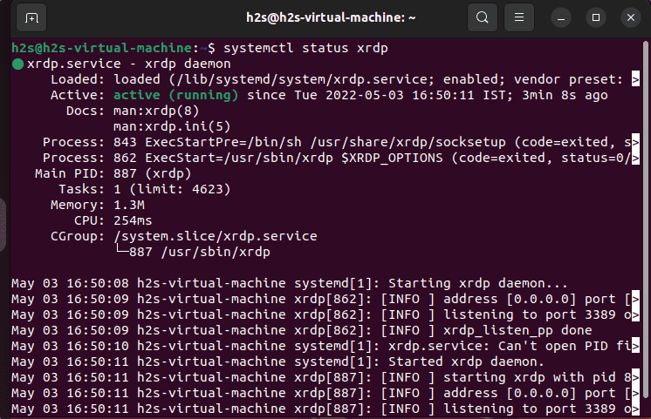

**4. Open port 3389 in the firewall**

To let the other systems in the network access Ubuntu 22.04 Jammy remotely over RDP, open the port number 3389 on your system’s firewall.

sudo ufw allow from any to any port 3389 proto tcp

**Next**, find the Ip-address of your Ubuntu system and note it down, somewhere. For that on your terminal run:

ip a

**5.  Log out Ubuntu 22.04**

Once the installation is completed, simply log out your Ubuntu 22.04 system otherwise you will get a black screen issue on Windows while connecting Ubuntu remotely using XRDP.

To log out, click on the **Power-off** icon and select the **logout** option.

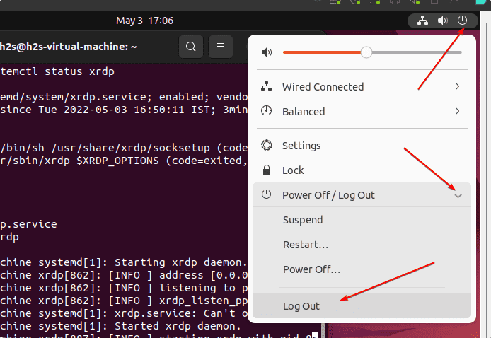

**6. Connect Ubuntu 22.o4 remotely using Windows 10 or 11**

Finally, go to the Windows 10 or 11 system you are using and click on the **Search** icon. There type “Remote Desktop Connection” as its icon appears, and click to open the same.

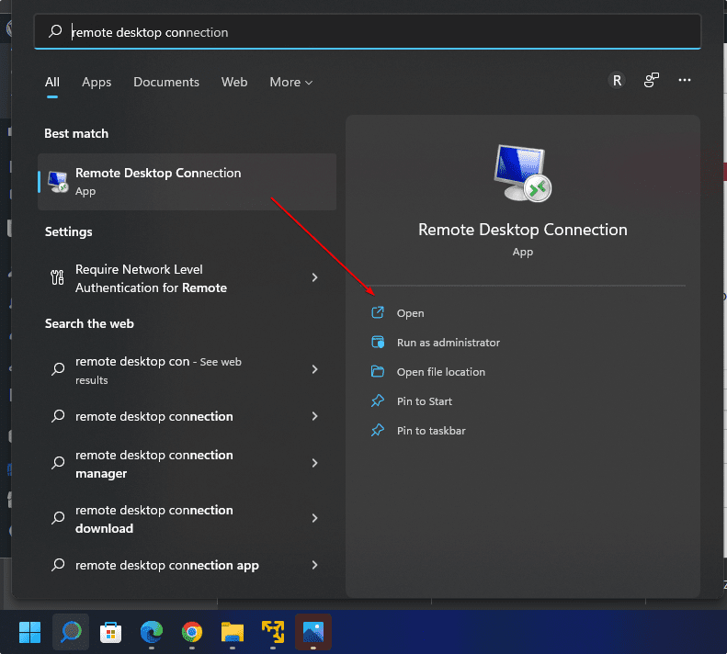

Enter the Ip-address of your Ubuntu system noted down by you, in the “Remote Desktop Connection” app of Windows and click on the “**Connect**” button.

**For example,** our Ubuntu 22.04 IP address was **192.168.17.133**

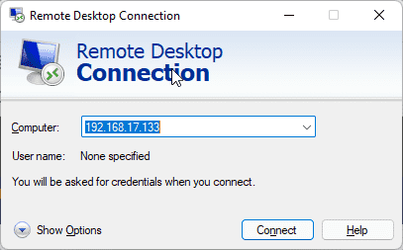

**When the message appears** “*The identity of the remote computer cannot be verified. Do you want to connect anyway?*”

Click the **Yes** button.

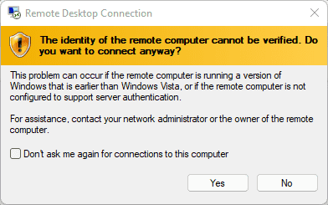

The XORG window will open, enter the **username** and **password** of your **remote Ubuntu 22.04** that you want to connect over RDP to control it graphically.

